Objective

This procedure establishes the process for conducting remote witness and conformity inspections by Burrana Inspectors, FAA Designated Engineering Representatives (DER), or Designated Airworthiness Representatives (DAR). The use of Remote Technology ensures compliance with:
- 14 CFR Part 21.137 – Production Approval Holder requirements.
- PS-AIR-21-1901 – Use of Remote Technology for Inspections and Testing.
- The Burrana Production Quality Manual – Compliance with Burrana’s internal Quality Management System.

Following FAA approval, any modifications affecting content require FAA re-submission.

Applicability

This procedure applies to:

Remote conformity inspections conducted by Burrana Inspectors, FAA DERs, and DARs.

Inspections and testing for Burrana-produced articles and those received from approved suppliers.

Remote witness inspections performed by FAA representatives or their delegates.

Burrana In-Flight Entertainment (IFE) products, classified as non-critical unless reclassified as critical.

Use of Remote Technology (e.g., live video and audio feeds) for inspection, ensuring compliance with FAA standards, video resolution, and qualified personnel.

Conformity documentation and verification through FAA Form 8100-1, FAA Form 8130-3, and QC-F-851-01.

Remote inspection processes must be conducted only at approved locations and by qualified personnel. Any change in the classification of parts (from non-critical to critical) requires reevaluation and FAA approval before remote inspection methods can be applied.

Responsibilities

Vice President of Quality
- Ensures implementation and compliance with FAA and Burrana QMS.
- Oversees continuous improvement efforts in remote conformity.

Accountable Manager (Authorized Representative - AR)
- As defined and approved by the FAA, responsible for maintaining compliance with FAA conformity expectations.
- Ensures all personnel conducting remote inspections are qualified and listed on F-851-07 Remote Inspection Authorized Locations and Personnel.
- Coordinates with regulatory authorities (FAA, DER, DAR) to facilitate inspections and resolve compliance-related issues.

Burrana Quality Manager
- Verifies that all remote inspectors and suppliers have the necessary training and qualifications.
- Ensures training, calibration, and environmental controls are met.

Burrana Quality Inspectors
- Perform remote inspections using live video and audio.
- Ensure documented conformity compliance per FAA Form 8100-1 and 8130-3.
- Identify and document nonconformances or process improvements in QwizPro.

FAA DER/DAR (Designated Representatives)
- Conduct remote FAA witness inspections as per Burrana and FAA-approved procedures.
- Validate conformity documentation and approve FAA release certificates.

Definitions
DAR | Designated Airworthiness Representative
DER | Designated Engineering Representative
AR | Authorized Representative
MRO | Maintenance and Repair Organization
IFE | In-Flight Entertainment
FOD | Foreign Object Damage
Form 8100-1 | FAA Conformity Inspection Record
Form 8130-3 | FAA Authorized Release Certificate
Form 8130-9 | FAA Statement of Conformity
Remote Technology | The technology that allows users to work from an off-site location

Scope
Remote inspections have become necessary due to world events, which can cause restrictions on travel. It is also providing an option to improve business processes in reducing cost and turnaround time for products and services.
This procedure provides the structure for not only Burrana Inspectors to carry out remote conformity inspections, but also to allow the FAA and their designated engineers to carry out remote witness and inspections on Burrana products.

Process for Remote Conformity
To issue an Authorized Release Certificate, refer to SPR-852-10 Issuance of FAA Form 8130-3.

Remote Technology
Burrana will use Remote Technology in the form of live video and audio feeds, for the remote conformity inspection of parts from remote location. These remote inspections or tests shall:
- Not be pre-recorded
- Not be conducted without scheduled timeframes
- Use equipment suitable to the inspection
- Utilize a resolution with enough detail to approve, without doubt, the parts conform to the written requirements
- Be conducted with appropriate instruction and personnel to conduct the remote test.
- Allow easy verbal communication
Burrana In-Flight Entertainment products (IFE) are considered “non-critical” parts and therefor Remote Technology would be considered appropriate when properly controlled. If at any time the status changes to a “Critical” part, this process will be re-evaluated and submitted to the FAA for additional approvals.
Burrana will record and keep the video and audio feeds whenever possible to include as a review during internal audit or to share with the DER/DAR as required.

Burrana Remote PMA Inspections

Personnel
Burrana takes into consideration the skills and training of the inspector completing the conformity inspection or testing and the supplier’s employee presenting that remote inspection or test.
It is the responsibility of the Burrana Quality Manager to verify the participating employees have the appropriate level of competency and that training is up to date.
It is the responsibility of the Burrana Quality Inspector to determine the appropriate tools, environment, tests, and key characteristics are identified before the implementation of the process for remote conformity.
Burrana will only use Remote Technology for a conformity on an approved supplier or MRO Facility with appropriate instruction and personnel to conduct the remote inspection. These personnel must be employees of the Burrana organization and listed on F-851-07 Remote Inspection Authorized Locations and Personnel.

Tools and environmental controls
Tools used for remote conformity inspection or testing shall be calibrated and the tool number and last calibration date recorded on QC-F-851-01 – Checklist for Remote Inspection form.
The environment used to do the Remote Conformity shall be free of excess distractions and controlled to the degree necessary to give confidence in the remote technology being used for the conformity or testing.
When necessary, multiple angles will be required to review key characteristics as well as extra lighting. When this occurs, those will be requested and noted on the documentation.
There are no unique testing devices needed for the conformity of Burrana IFE Products.

In the event of an inspection interruption
Burrana will re-validate any test or inspection that is interrupted by environmental or mechanical failures to maintain confidence in the conformity inspection or test.

Failure of Equipment or incomplete inspection
If for any reason, there is an equipment failure the inspector will take into consideration one or more of the following:
- A secondary inspection or test may be conducted if the failure can be rectified, or
- The product will be shipped to our location to complete per our requirements, or
- A qualified quality control technician will travel to the facility to inspect in person
- This anomaly shall be recorded on the test or inspection documentation
The Burrana inspector will document per P-870-01 - Control of Nonconforming Outputs any failures discovered during the remote viewing process.

Improvement
The Burrana inspector will document any opportunities for improvement discovered during the remote viewing process per the Corrective Actions module in QwizPro per P-1020-01
This is to allow for future improvements and review by the management team to create a more secure and reliable system for remote inspection or test.

Documented Information
The inspector completing the remote inspection of production articles will document the inspection process using QC-F-851-01 – Checklist for Remote Inspection form, recording key characteristics and documents reviewed to determine conformity during the remote inspection.
QC-F-851-01 consists of several questions that relate to the conformity of the product, as well as safety, environment, and documentation. Further care is taken in efforts to prevent FOD and other issues identified through lessons learned.
The form contains a tab for PMA articles, MRO articles, Instructions, and an 8100-1 embedded form, each on an identified tab.
When Remote conformity is completed at an approved supplier, a final inspection is provided for review in advance of the scheduled remote inspection to validate dimensional inspections.

Remote Testing/Test Witnessing
For remote testing the test procedures will be filled out onsite and provided to the remote witnessing Burrana Engineer for completion and signing the remote test report.
Additionally, Burrana will provide an agent letter to the appropriate designee allowing them to sign the FAA Forms, or any other required documentation, needed for installation conformity prior to the test event.
8100-1 may be disregarded when deemed appropriate based on the assessment of the inspector.

FAA Testing on Burrana Products
FAA and their delegates can use this procedure to carry out remote witness and inspections on Burrana products.
Note: This remote Conformity and Test Witnessing procedure must be references in the applicable DAR/DER procedures.
The DER/DAR is to use FAA Form 8100-1 in place of the Burrana QC-F-851-01 – Checklist for Remote Inspection form to capture the inspection results.
For remote functional testing, the test procedures will be filled out onsite and provided to the remote witnessing DER for completion and signing the remote test report.

Internal Audit Process
Burrana follows an internal audit process, which is documented in CORP-P-920-01 (Internal Audits) and recorded in QwizPro for retrieval and review. The process to review this Remote Conformity and Test Witnessing procedure will be included in this audit cycle as a separately identified procedural audit and will include:

Review of this procedure
Review of supporting documents used during remote conformity inspections or tests
Review of 3 (if available) Remote Conformity or test approvals, at random, to verify process adherence
Review of training records and certificates for those approved to complete remote conformities and tests.

Production Conformity Inspection
A Production or prototype Conformity is defined as the Validation of an article produced by Burrana Inc. or a qualified supplier that has undergone approval using the Burrana Quality Management System.
Burrana will follow the Process Flow Diagram (Appendix 1, 2 and 3) for determination of remote conformity or test needs. This document will also be required to be reflected in the suppliers Quality Documentation regarding Conformity Inspections.

Records
- FAA Form 8100-1
- FAA Form 8130-9
- FAA Form 8130-3

Governing Standards
- PS – AIR – 21 – 1901 Use of Remote Technology During the Performance of Inspections and Tests
- FAA 14 CFR part 21.137 a-o
- FAA 14 CFR 21.137 o
- AS9100
- AS9103
- AS9110

Related Processes
CORP-P-720-01 Competence & Awareness
CORP-P-720-02 Certification Training
CORP-P-811-01 Operational Risk Management
P-920-01 Internal Audits
PQM-422-1 PMA STC Quality Manual
QA-P-750-01 Control of Documented Information
QA-P-930-01 Management Review
QC-P-851-04 Control of Production and Service Provision
P-870-01 Control of Non-Conforming Outputs
QC-P-870-02 COS Response Team
QC-P-715-01 Control of Monitoring and Measuring Equipment
QC-F-851-01 Checklist for Remote Inspection
OPS-P-1010-01 Improvement
F-851-07 Remote Inspection Authorized Locations and Personnel

Metrics
Burrana KPI for Quality is <2% escapes

Training
Employees listed on the F-851-07 are trained in this procedure

Opportunities and Risks
The P-600-01 (Planning for the Quality Management System) procedure addresses opportunities and risks (risk-based thinking).
Burrana makes use of organizational knowledge, lessons learned and experience with the activities associated with Improvement to determine opportunities and risks that need to be addressed and which can:
- Give assurance that the procedure can achieve its intended result(s).
- Enhance desirable effects and prevent or reduce undesired effects.
- Achieve improvement.
- Whenever necessary, this information is documented.

Appendix 1
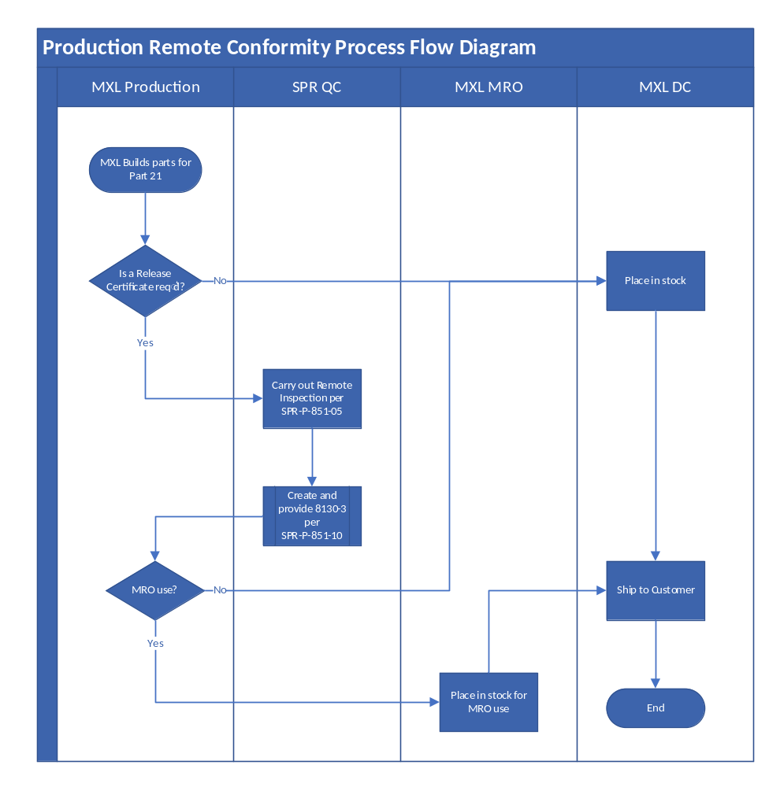

Appendix 2
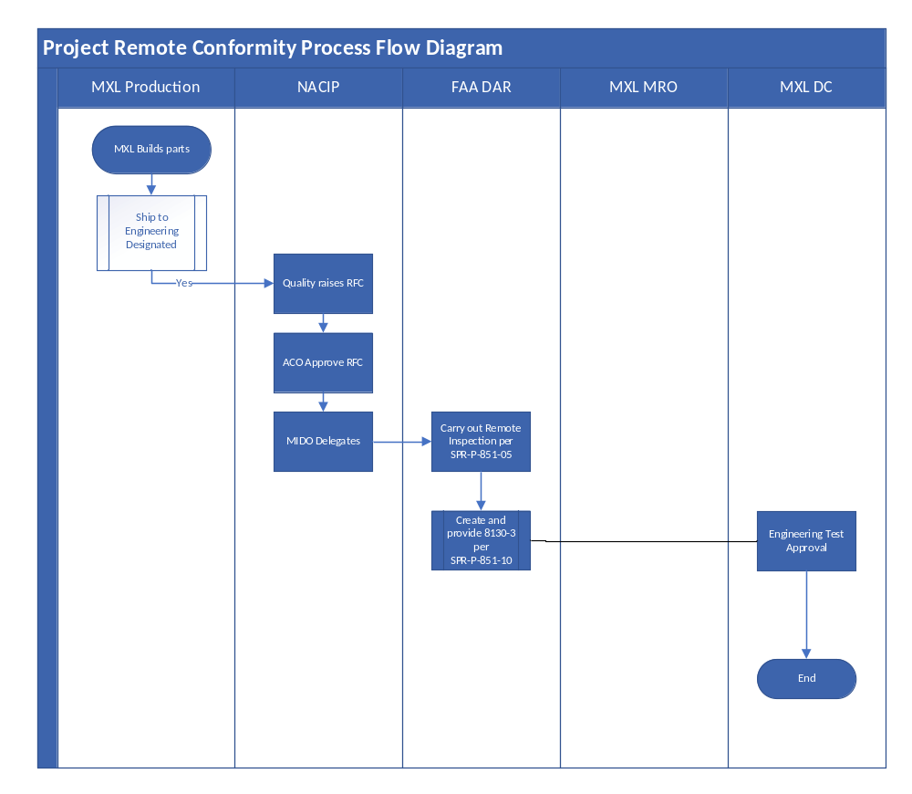

Appendix 3
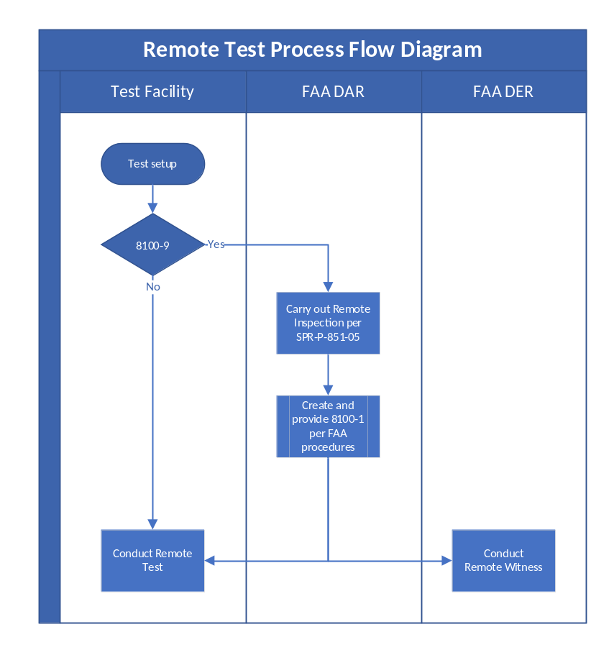

Objetivo

Este procedimiento establece el proceso para llevar a cabo inspecciones remotas de testigos y conformidad por parte de los inspectores de Burrana, los representantes de ingeniería designados por la FAA (DER) o los representantes de aeronavegabilidad designados (DAR). El uso de la Tecnología Remota garantiza el cumplimiento de:
- 14 CFR Parte 21.137 - Requisitos del titular de la aprobación de producción.
- PS-AIR-21-1901 – Uso de tecnología remota para inspecciones y pruebas.
- Manual de Calidad de Producción de Burrana – Cumplimiento del Sistema de Gestión de Calidad interno de Burrana.

Después de la aprobación de la FAA, cualquier modificación que afecte el contenido requiere que la FAA vuelva a presentarla.

Aplicabilidad

Este procedimiento se aplica a:

Inspecciones de conformidad remotas realizadas por inspectores de Burrana, FAA DER y DAR.

Inspecciones y pruebas para los artículos producidos por Burrana y los recibidos de proveedores aprobados.

Inspecciones de testigos remotos realizadas por representantes de la FAA o sus delegados.

Productos de Burrana In-Flight Entertainment (IFE), clasificados como no críticos a menos que se reclasifiquen como críticos.

Uso de tecnología remota (por ejemplo, transmisiones de audio y video en vivo) para la inspección, lo que garantiza el cumplimiento de los estándares de la FAA, la resolución de video y el personal calificado.

Documentación y verificación de conformidad a través del Formulario FAA 8100-1, Formulario FAA 8130-3 y QC-F-851-01.

Los procesos de inspección remota deben realizarse solo en ubicaciones aprobadas y por personal calificado. Cualquier cambio en la clasificación de las piezas (de no críticas a críticas) requiere una reevaluación y la aprobación de la FAA antes de que se puedan aplicar los métodos de inspección remota.

Responsabilidades

Vicepresidente de Calidad
- Garantiza la implementación y el cumplimiento de FAA y Burrana QMS.
- Supervisa los esfuerzos de mejora continua en la conformidad remota.

Gerente Responsable (Representante Autorizado - AR)
- Según lo definido y aprobado por la FAA, responsable de mantener el cumplimiento de las expectativas de conformidad de la FAA.
- Garantiza que todo el personal que realiza inspecciones remotas esté calificado y figuren en F-851-07 Ubicaciones y personal autorizados de inspección remota.
- Coordina con las autoridades reguladoras (FAA, DER, DAR) para facilitar las inspecciones y resolver problemas relacionados con el cumplimiento.

Gerente de Calidad de Burrana
- Verifica que todos los inspectores y proveedores remotos tengan la capacitación y las calificaciones necesarias.
- Garantiza que se cumplan los controles de capacitación, calibración y entorno.

Inspectores de calidad de Burrana
- Realice inspecciones remotas utilizando video y audio en vivo.
- Garantice el cumplimiento de la conformidad documentada según los formularios 8100-1 y 8130-3 de la FAA.
- Identifique y documente las no conformidades o las mejoras de procesos en QwizPro.

FAA DER/DAR (Representantes Designados)
- Realizar inspecciones remotas de testigos de la FAA según Burrana y los procedimientos aprobados por la FAA.
- Valide la documentación de conformidad y apruebe los certificados de liberación de la FAA.

Definiciones
DAR | Representante de Aeronavegabilidad Designado
DER | Representante de Ingeniería Designado
AR | Representante Autorizado
MRO (en inglés) | Organización de Mantenimiento y Reparación
IFE | Entretenimiento a bordo
DU | Daños por objetos extraños
Formulario 8100-1 | Registro de inspección de conformidad de la FAA
Formulario 8130-3 | Certificado de Liberación Autorizado por la FAA
Formulario 8130-9 | Declaración de conformidad de la FAA
Tecnología remota | La tecnología que permite a los usuarios trabajar desde una ubicación externa

Alcance
Las inspecciones remotas se han vuelto necesarias debido a los eventos mundiales, lo que puede causar restricciones para viajar. También proporciona una opción para mejorar los procesos comerciales al reducir los costos y el tiempo de respuesta de los productos y servicios.
Este procedimiento proporciona la estructura no solo para que los inspectores de Burrana lleven a cabo inspecciones de conformidad remotas, sino que también permita que la FAA y sus ingenieros designados lleven a cabo inspecciones y testigos remotos en los productos de Burrana.

Proceso de Conformidad Remota
Para emitir un Certificado de Liberación Autorizado, consulte SPR-852-10 Emisión del Formulario FAA 8130-3.

Tecnología remota
Burrana utilizará la tecnología remota en forma de transmisiones de audio y video en vivo, para la inspección remota de la conformidad de las piezas desde una ubicación remota. Estas inspecciones o ensayos a distancia deberán:
- No estar pregrabado
- No se llevará a cabo sin plazos programados.
- Utilizar equipos adecuados para la inspección
- Utilice una resolución con suficiente detalle para aprobar, sin lugar a dudas, que las piezas se ajustan a los requisitos escritos
- Ser conducido con la instrucción y el personal adecuados para llevar a cabo la prueba a distancia.
- Permitir una comunicación verbal fácil
Los productos de entretenimiento a bordo (IFE) de Burrana se consideran partes "no críticas" y, por lo tanto, la tecnología remota se consideraría apropiada cuando se controle adecuadamente. Si en algún momento el estado cambia a una parte "Crítica", este proceso se volverá a evaluar y se enviará a la FAA para aprobaciones adicionales.
Burrana grabará y conservará las transmisiones de video y audio siempre que sea posible para incluirlas como revisión durante la auditoría interna o para compartirlas con el DER/DAR según sea necesario.

Inspecciones remotas de PMA de Burrana

Personal
Burrana tiene en cuenta las habilidades y la capacitación del inspector que realiza la inspección o prueba de conformidad y del empleado del proveedor que presenta esa inspección o prueba remota.
Es responsabilidad del Gerente de Calidad de Burrana verificar que los empleados participantes tengan el nivel adecuado de competencia y que la capacitación esté actualizada.
Es responsabilidad del Inspector de Calidad de Burrana determinar las herramientas adecuadas, el entorno, las pruebas y las características clave que se identifican antes de la implementación del proceso de conformidad remota.
Burrana solo utilizará la tecnología remota para una conformidad en un proveedor aprobado o una instalación de MRO con las instrucciones y el personal adecuados para realizar la inspección remota. Este personal debe ser empleado de la organización Burrana y estar listado en F-851-07 Ubicaciones y Personal Autorizados de Inspección Remota.

Herramientas y controles ambientales
Las herramientas utilizadas para la inspección o prueba de conformidad remota se calibrarán y el número de herramienta y la fecha de la última calibración se registrarán en el formulario QC-F-851-01 - Lista de verificación para la inspección remota.
El entorno utilizado para realizar la conformidad a distancia estará libre de distracciones excesivas y controlado en la medida necesaria para dar confianza en la tecnología a distancia que se utiliza para la conformidad o las pruebas.
Cuando sea necesario, se requerirán múltiples ángulos para revisar las características clave, así como la iluminación adicional. Cuando esto ocurra, se solicitarán y anotarán en la documentación.
No se necesitan dispositivos de prueba únicos para la conformidad de los productos Burrana IFE.

En caso de interrupción de la inspección
Burrana volverá a validar cualquier prueba o inspección que se vea interrumpida por fallas ambientales o mecánicas para mantener la confianza en la inspección o prueba de conformidad.

Falla del equipo o inspección incompleta
Si por alguna razón, hay una falla en el equipo, el inspector tomará en consideración uno o más de los siguientes:
Se puede realizar una inspección o prueba secundaria si la falla se puede rectificar, o
El producto se enviará a nuestra ubicación para completarlo según nuestros requisitos, o
Un técnico de control de calidad calificado viajará a las instalaciones para inspeccionar en persona
Esta anomalía se registrará en la documentación de ensayo o inspección
El inspector de Burrana documentará según P-870-01 - Control de salidas no conformes cualquier falla descubierta durante el proceso de visualización remota.

Mejora
El inspector de Burrana documentará cualquier oportunidad de mejora descubierta durante el proceso de visualización remota según el módulo de Acciones Correctivas en QwizPro según P-1020-01
Esto es para permitir futuras mejoras y revisiones por parte del equipo de gestión para crear un sistema más seguro y confiable para la inspección o prueba remota.

Información documentada
El inspector que complete la inspección remota de los artículos de producción documentará el proceso de inspección utilizando el formulario QC-F-851-01 - Lista de verificación para la inspección remota, registrando las características clave y los documentos revisados para determinar la conformidad durante la inspección remota.
QC-F-851-01 consta de varias preguntas relacionadas con la conformidad del producto, así como con la seguridad, el medio ambiente y la documentación. Se presta más atención a los esfuerzos por prevenir la FOD y otros problemas identificados a través de las lecciones aprendidas.
El formulario contiene una pestaña para artículos de PMA, artículos de MRO, instrucciones y un formulario incrustado 8100-1, cada uno en una pestaña identificada.
Cuando se completa la conformidad remota en un proveedor aprobado, se proporciona una inspección final para su revisión antes de la inspección remota programada para validar las inspecciones dimensionales.

Pruebas Remotas/Testificación de Pruebas
Para las pruebas remotas, los procedimientos de prueba se completarán en el sitio y se proporcionarán al ingeniero de Burrana testigo remoto para que lo complete y firme el informe de prueba remota.
Además, Burrana proporcionará una carta de agente a la persona designada apropiada que le permitirá firmar los formularios de la FAA, o cualquier otra documentación requerida, necesaria para la conformidad de la instalación antes del evento de prueba.
8100-1 puede ser descartado cuando se considere apropiado en base a la evaluación del inspector.

Pruebas de la FAA en productos Burrana
La FAA y sus delegados pueden utilizar este procedimiento para llevar a cabo inspecciones y testigos remotos en los productos Burrana.
Nota: Este procedimiento remoto de Conformidad y Testificación debe ser referencia en los procedimientos DAR/DER aplicables.
El DER/DAR debe utilizar el Formulario 8100-1 de la FAA en lugar del formulario Burrana QC-F-851-01 - Lista de verificación para la inspección remota para capturar los resultados de la inspección.
Para las pruebas funcionales remotas, los procedimientos de prueba se completarán en el sitio y se proporcionarán al DER testigo remoto para que lo complete y firme el informe de prueba remota.

Proceso de Auditoría Interna
Burrana sigue un proceso de auditoría interna, que se documenta en CORP-P-920-01 (Auditorías internas) y se registra en QwizPro para su recuperación y revisión. El proceso para revisar este procedimiento de Conformidad Remota y Testigos de Pruebas se incluirá en este ciclo de auditoría como una auditoría de procedimiento identificada por separado e incluirá:

Revisión de este procedimiento
Revisión de los documentos justificativos utilizados durante las inspecciones o ensayos de conformidad a distancia
Revisión de 3 (si están disponibles) aprobaciones de conformidad remota o pruebas, al azar, para verificar el cumplimiento del proceso
Revisión de los registros de capacitación y certificados de aquellos aprobados para completar conformidades y pruebas remotas.

Inspección de conformidad de la producción
Una Conformidad de Producción o prototipo se define como la Validación de un artículo producido por Burrana Inc. o un proveedor calificado que ha sido aprobado utilizando el Sistema de Gestión de Calidad de Burrana.
Burrana seguirá el Diagrama de Flujo del Proceso (Apéndices 1, 2 y 3) para la determinación de la conformidad remota o las necesidades de prueba. Este documento también deberá reflejarse en la Documentación de Calidad de los proveedores en materia de Inspecciones de Conformidad.

Archivo
- Formulario 8100-1 de la FAA
- Formulario 8130-9 de la FAA
- Formulario 8130-3 de la FAA

Normas que rigen
- PS – AIR – 21 – 1901 Uso de tecnología remota durante la realización de inspecciones y pruebas
- 14 CFR parte 21.137 a.m.
- FAA 14 CFR 21.137 o
- AS9100
- AS9103
- AS9110

Procesos relacionados
CORP-P-720-01 Competencia y Conciencia
CORP-P-720-02 Capacitación de Certificación
CORP-P-811-01 Gestión de Riesgo Operacional
P-920-01 Auditorías Internas
PQM-422-1 PMA STC Manual de Calidad
QA-P-750-01 Control de Información Documentada
QA-P-930-01 Revisión por la Dirección
QC-P-851-04 Control de Producción y Prestación de Servicios
P-870-01 Control de Salidas No Conformes
QC-P-870-02 Equipo de Respuesta COS
QC-P-715-01 Control de Equipos de Monitoreo y Medición
QC-F-851-01 Lista de verificación para inspección remota
Mejora de OPS-P-1010-01
F-851-07 Inspección Remota Ubicaciones y Personal Autorizados

Métricas
El KPI de Burrana para la calidad es de <2% de escapes

Adiestramiento
Los empleados enumerados en el F-851-07 están capacitados en este procedimiento

Oportunidades y riesgos
El procedimiento P-600-01 (Planificación del Sistema de Gestión de la Calidad) aborda las oportunidades y los riesgos (pensamiento basado en el riesgo).
Burrana hace uso del conocimiento organizacional, las lecciones aprendidas y la experiencia con las actividades asociadas con la Mejora para determinar las oportunidades y los riesgos que deben abordarse y que pueden:
- Dar garantías de que el procedimiento puede lograr los resultados previstos.
- Mejorar los efectos deseables y prevenir o reducir los efectos no deseados.
- Lograr la mejora.
- Siempre que sea necesario, esta información se documenta.

Apéndice 1

Apéndice 2

Apéndice 3

